

Syed Imran Syed Imam, EKSfmc-15 group student

Subject: Open Source Software for Science, Business and Management.

**Reason:**

GitHub is a great service, however there are some limitations and restrictions, especially if you are an individual or a small player. One of the limitations of GitHub is that the free service doesn’t allow private hosting of the code.

Projects on GitHub can be accessed and manipulated using the standard Git command-line interface and all of the standard Git commands work with it. GitHub also allows registered and non-registered users to browse public repositories on the site. Multiple desktop clients and Git [plugins](https://en.wikipedia.org/wiki/Plug-in_(computing)) have also been created by GitHub and other third parties that integrate with the platform.

GitHub reports having more than 14 million users and more than 35 million repositories, making it the largest host of source code in the world.

GitHub offers both plans for private [repositories](https://en.wikipedia.org/wiki/Repository_(version_control)), and free accountswhich are commonly used to host [open-source](https://en.wikipedia.org/wiki/Open-source) software projects.

**Link local repository with online one:**

1) https://github.com/syedsultan/flintoff#flintoff

2) <https://github.com/miller3/syed>

**Create a new text file in your local repository, commit and push to repo:**

**Example:**

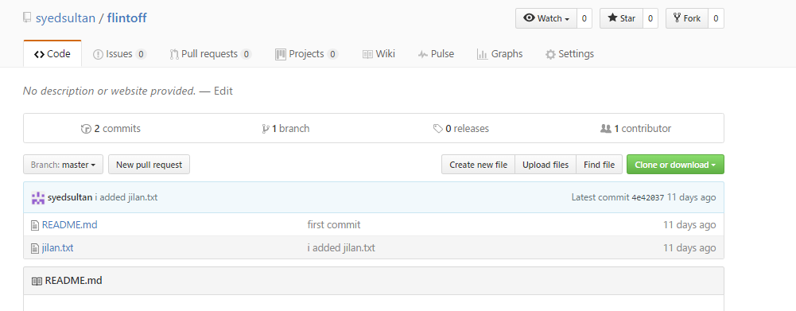

**I created one more GitHub account to collaborate:**

Repo:

<https://github.com/miller3/syed>

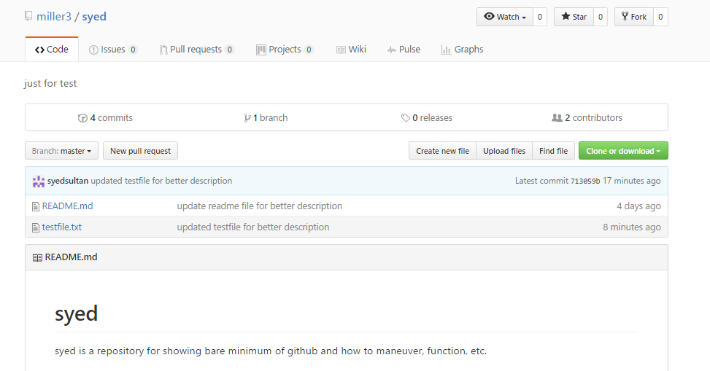

**Collaborate both accounts:**

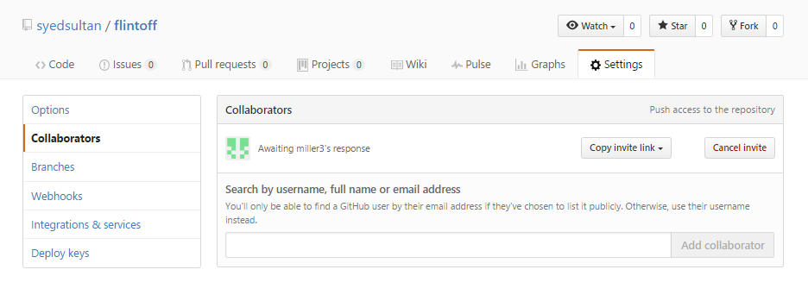

Collaborate two repositories: <https://github.com/miller3/syed/graphs/contributors>

Sample graph:

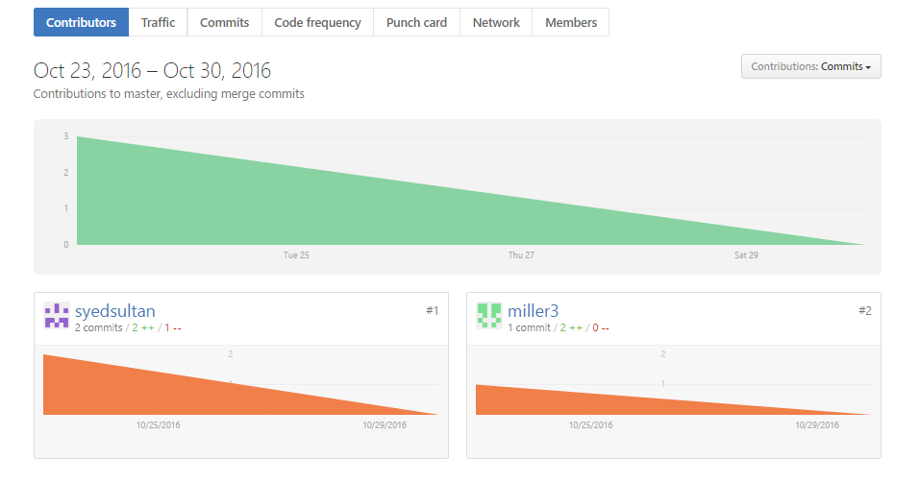

**Update the file just for checking:**

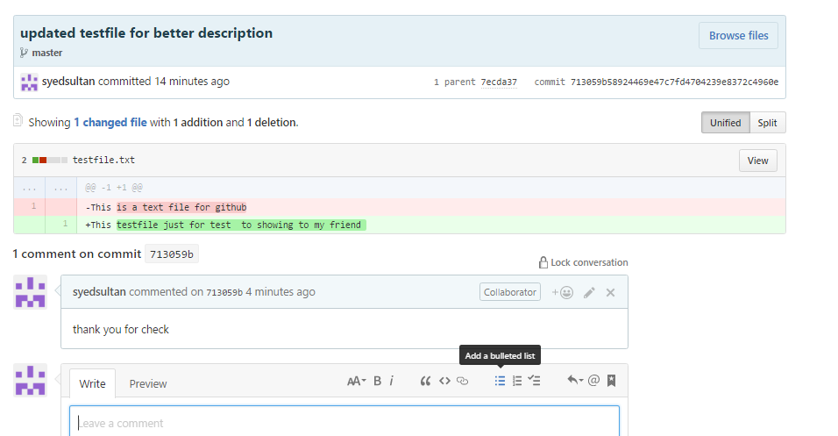

**Pull text file from online to their local repository:**



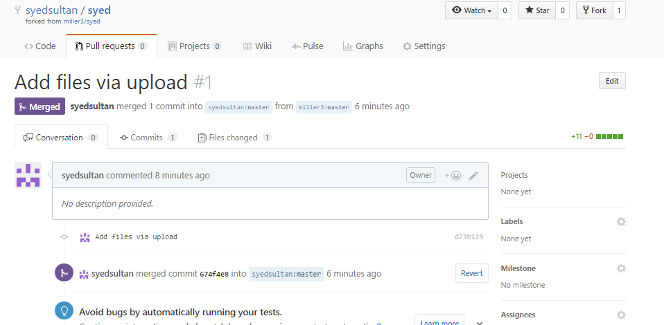

**Merging both accounts:**

Example:

